

We need 2 drop down lists, one for supplier and one for member.

We need to change username to Name, and out the user’s real name in that column instead of username.

If a user is not assigned to member-confidential user group then terms checkbox should not be available for that user.

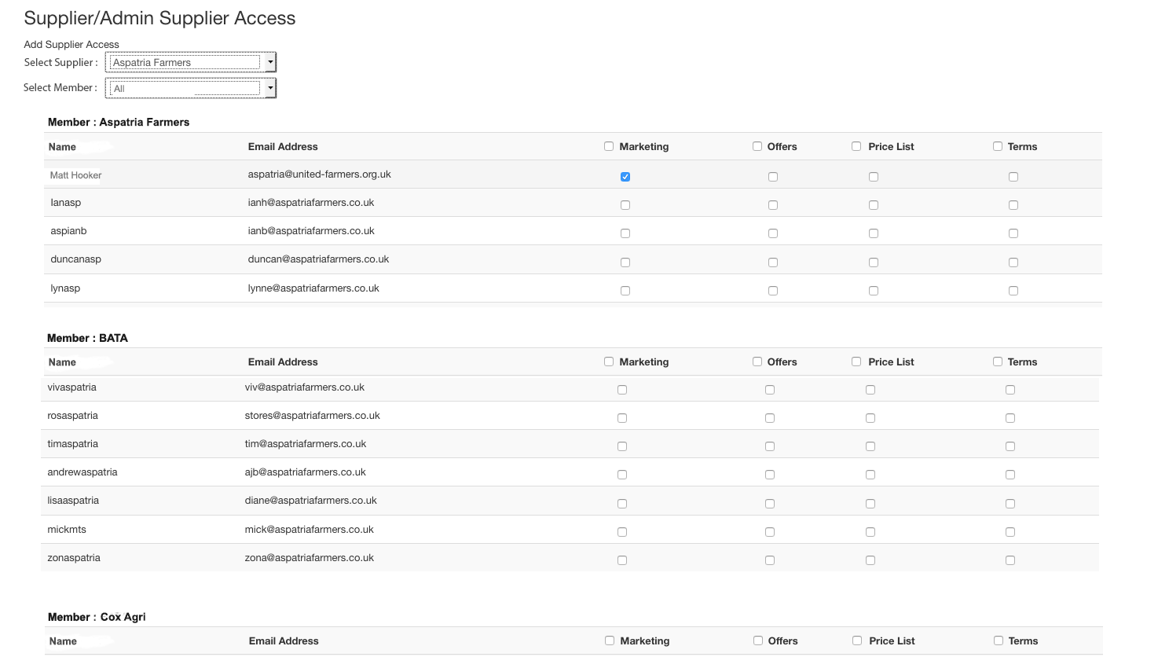

If admin user selects All in member dropdown, then ALL members and their users should be show (as in diagram)